LAB EXPERIMENT RECORD

SET 12 — Website Traffic Analysis

Department | AIDS
Course Code / Course Name | DSA0602 / Data Handling and Visualization
Experiment | Data Visualization using R
Name | GOPIKHA S
Register Number | 1924260143
Date | 6 October 2026
Day | Tuesday

Aim

To analyze website traffic data using R by creating a line chart for daily page views, a bar chart for the top N days based on click-through rate, a website traffic table, and an interactive R Shiny dashboard.

Dataset

Website Traffic Dataset

Date | Page Views | Click-through Rate
2023-01-01 | 1500 | 2.3%
2023-01-02 | 1600 | 2.7%
2023-01-03 | 1400 | 2.0%

Program 1 — Line Chart for Daily Page Views

Aim

To create a line chart showing the trend in daily website page views.

R Code

# Website Traffic Data

date <- as.Date(c( "2023-01-01",
"2023-01-02",
"2023-01-03"
))

page_views <- c( 1500,
1600,
1400
)

traffic_data <- data.frame( Date = date,
Page_Views = page_views
)

# Create line chart

plot( traffic_data$Date,
traffic_data$Page_Views,

type = "o",
main = "Daily Website Page Views", xlab = "Date",
ylab = "Page Views"
)
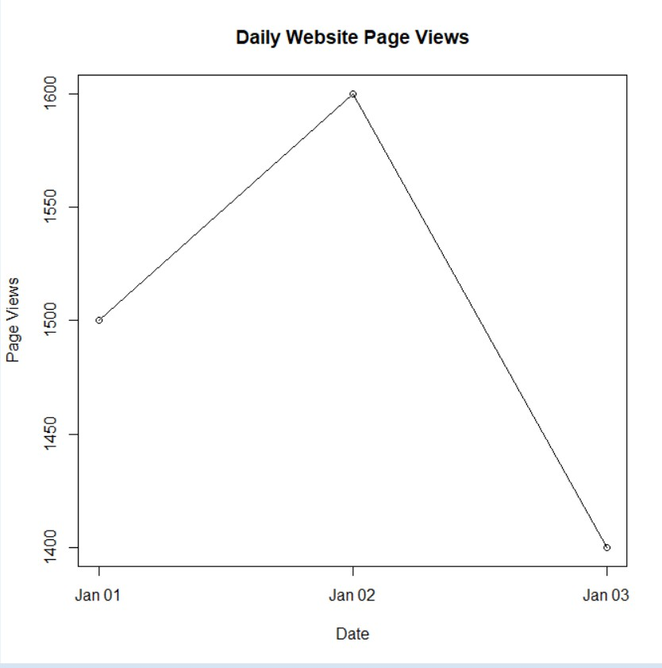

Observation

The line chart shows the daily trend in website page views. Page views increased to 1600 on January 2 and then decreased to 1400 on January 3.\

Program 2 — Bar Chart for Top N Days by CTR

Aim

To create a bar chart showing the days with the highest click-through rate.

R Code

# Website Traffic Data

date <- as.Date(c( "2023-01-01",
"2023-01-02",
"2023-01-03"
))

ctr <- c( 2.3,
2.7,
2.0
)

traffic_data <- data.frame( Date = date,
CTR = ctr
)

# Sort data by CTR

traffic_data <- traffic_data[ order(-traffic_data$CTR),
]

# Select Top 3 Days

top_n <- head( traffic_data, 3
)

# Create bar chart

barplot( top_n$CTR,
names.arg = format( top_n$Date,
"%Y-%m-%d"
),
main = "Top Days by Click-through Rate", xlab = "Date",
ylab = "Click-through Rate (%)"
)

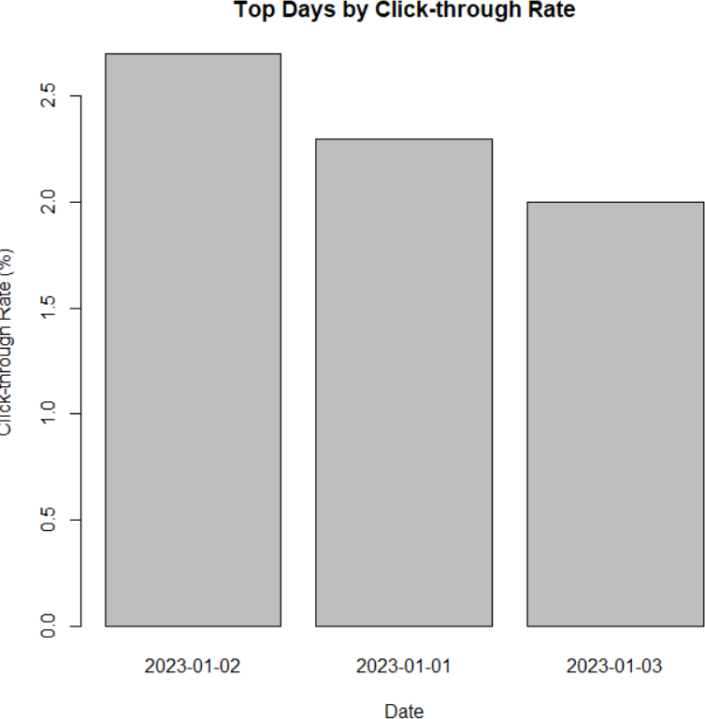

Observation

The bar chart shows that 2023-01-02 has the highest click-through rate of 2.7%, followed by
2023-01-01 with 2.3% and 2023-01-03 with 2.0%.

Program 3 — Website Traffic Data Table

Aim

To create and display a table containing website traffic information.

R Code

# Website Traffic Data

traffic_data <- data.frame( Date = as.Date(c(
"2023-01-01",
"2023-01-02",
"2023-01-03"
)),
Page_Views = c( 1500,
1600,
1400
),
Click_Through_Rate = c( 2.3,
2.7,
2.0
)
)

# Display table traffic_data

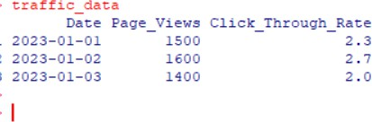

Observation

The table displays the date, number of page views, and click-through rate for each day.

Program 4 — R Shiny Interactive Dashboard

Aim

To develop an interactive dashboard combining the line chart, bar chart, and website traffic table using R Shiny.

R Code

# Install package if required # install.packages("shiny")

library(shiny)

# Website Traffic Dataset

traffic_data <- data.frame( Date = as.Date(c(
"2023-01-01",
"2023-01-02",
"2023-01-03"
)), Page_Views = c(

1500,
1600,
1400
),
CTR = c( 2.3,
2.7,
2.0
)
)

# UI

ui <- fluidPage(

titlePanel(
"Website Traffic Analysis Dashboard"
),

tabsetPanel(

tabPanel( "Page Views",
plotOutput("lineChart")
),

tabPanel(
"Top CTR Days", plotOutput("barChart")
),

tabPanel( "Traffic Table",
tableOutput("trafficTable")
)

)
)

# Server

server <- function(input, output) { # Line Chart
output$lineChart <- renderPlot({

plot( traffic_data$Date,
traffic_data$Page_Views, type = "o",
main = "Daily Website Page Views", xlab = "Date",
ylab = "Page Views"
)

})

# Bar Chart

output$barChart <- renderPlot({

sorted_data <- traffic_data[ order(-traffic_data$CTR),
]

top_n <- head( sorted_data, 3
)

barplot( top_n$CTR,
names.arg = format( top_n$Date,
"%Y-%m-%d"
),
main = "Top Days by Click-through Rate", xlab = "Date",
ylab = "Click-through Rate (%)"
)

})

# Traffic Table

output$trafficTable <- renderTable({ traffic_data
})

}

# Run Shiny Application

shinyApp( ui = ui,
server = server
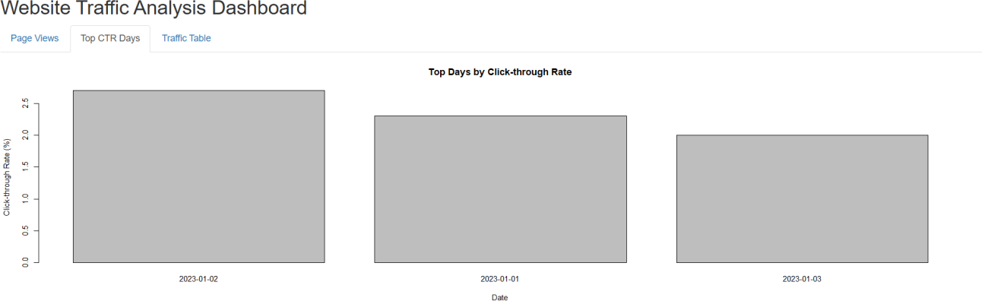
)

Observation

The R Shiny dashboard provides an interactive interface containing the daily page-view line chart, top CTR bar chart, and website traffic table. The dashboard allows the website traffic information to be viewed in multiple formats.

Overall Procedure

  - Create the website traffic dataset in R.
  - Store the date, page views, and click-through rate values.
  - Create a line chart to visualize daily page views.
  - Sort the data according to click-through rate.
  - Create a bar chart for the top N days.
  - Create and display the website traffic data table.
  - Develop an interactive R Shiny dashboard.
  - Add the line chart, bar chart, and table to the dashboard.

Result

The website traffic data was successfully analyzed and visualized using R. The line chart, CTR bar chart, traffic table, and R Shiny dashboard clearly represent the website traffic information.
The analysis shows that 2023-01-02 recorded the highest page views (1600) and the highest click-through rate (2.7%) among the given dates.

Key R Functions Used

Function | Purpose
data.frame() | Creates the website traffic dataset
as.Date() | Converts values into date format
plot() | Creates the line chart
barplot() | Creates the bar chart
order() | Sorts data by CTR
head() | Selects the top N records
format() | Formats dates for display
library(shiny) | Loads the Shiny package
fluidPage() | Creates the Shiny interface
tabsetPanel() | Creates dashboard tabs
plotOutput() | Displays plots in Shiny
renderPlot() | Generates plots dynamically
tableOutput() | Displays the data table
renderTable() | Generates the table
shinyApp() | Runs the Shiny application

